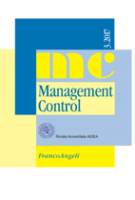

10th WORKSHOP OF MANAGEMENT CONTROL JOURNAL
Macerata, Italy, November 26–27, 2021

INTEGRATED DATA MANAGEMENT: NEW PERSPECTIVES
FOR CORPORATE GOVERNANCE AND MANAGEMENT CONTROL

Friday, 26th November
Verde room, Polo Pantaleoni, via della Pescheria Vecchia, 1 and online on Teams

15:15 Welcome and introduction to the workshop

Elena Cedrola
director of Department of Economics and Law
Antonella Paolini
member of scientific committee of Management Control journal and organizing committee of the workshop
Luciano Marchi
editor in chief of Management Control journal

16:00 Parallel sessions

Verde room

Gialla room

Viola 3 room

18:15 Editorial board of the Management Control journal meeting

20:30 Social dinner

Saturday, 27th November
Verde room, Polo Pantaleoni, via della Pescheria Vecchia, 1 and online on Teams

9:00 Parallel sessions

Verde room

Gialla room

Viola 3 room

11:00 Plenary session and workshop closing

